Readme of FaceOS Intelligent Refrigerator System for GeneralMills
Jun 8th,2018,Shanghai，by gale.wang FaceOS

Algorithms or solutions
- Face Detection
- Face Trackking
- Face Recognition

Azure Service
- Azure Storage
- Azure Data Science VM
- Azure Machine Learning Service
- Azure My SQL DB
- Azure Power BI

Architecture
FaceOS Intelligent Refrigerator System based on the “Cloud + Terminal” structure.

Result
FaceOS Intelligent Refrigerator System gather and analyze the guests & customers face image data, control the Refrigerator provides excellent service to the people. And also collect and mining the data value, help the enterprise to make business decision and improve their customer service. The working process diagram see the follow chart.

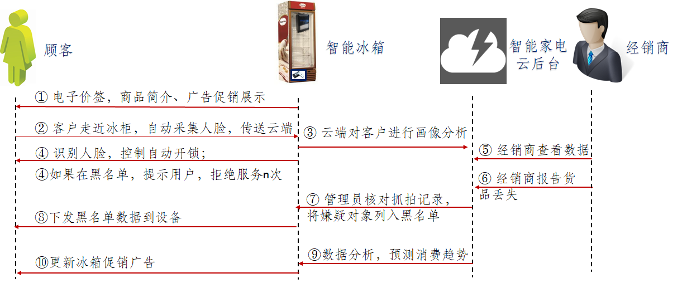
working process diagram

